The Fringe – Investor’s Demo & Biz Plan
Rick Pingry; November 11, 2007

This document describes the high level design and the tasks required to complete the first demo of The Fringe, which is just enough to get into the hands of our potential investors. This document is NOT about artistic or story decisions, although we do want to get a feel for the artistic content tasks that need to be performed. The goal is to get enough of a use case and design down that we can make a decent stab at the tasks that are to be performed for the first demo. Using this task list, we can get a better feel for the time to completion of this demo.

Demo Description
This demo is made to be just enough for a potential investor to see that we are motivated and capable of creating a great product. It will be something that we can show investors as we are presenting the opportunity to them. It will NOT be multi-player (although we will probably develop multi-player versions of such). As for delivery methods, we will probably show it off on my laptop, but people may also want to install it and play it on their local machines via CD and/or Web Site Install (we will have to warn them that we have not tested this on all configurations). The installer should place a short-cut on the desktop that will launch the client and the server and hook them all up, then run the viewer in full-screen mode.

We might also use an AVI to start drumming up some early interest, depending on how much focus the art department is going to be able to provide versus the engineers.

While the game loads, we can have a spinning logo and music. Once the game starts, we will need to give SOME instruction for players that are installing it themselves as to what to do in the game. I would imagine the ship starts off in the hanger with a text help screen up that tells players essentially what to do, how to launch their ship, how to fly, how to get the help screen back, and how to exit the game.

In the game, the player flies a fighter that starts off in the hanger bay of his battle group, and launches from there. The battle group consists of a few medium sized ships, including his launch ship. The battle group is traveling around a planet to sneak up on a large enemy capital ship. The player’s objective is to get to the large enemy capital ship before his battle group does and take out the ship killer cannons before his group gets in range, so that they can fire their weapons and destroy the enemy ship. The player may be destroyed multiple times, and each time, he returns to the hanger if his launch ship remains. If the player succeeds, he will see his battle group take out the enemy ship with a FANTASTIC explosion. If he fails, the enemy ship will take out his battle group (specifically his launch ship at the rear of the battle group) with some pretty spectacular explosions. Either way, as the ships are going down, a text screen will display his success or failure and allow him to play again or quit.

As the player launches, he will be able to fly around his battle group and get a feel for his fighter’s capabilities. The ship will fly much like a ship from Star Wars – Battlefront II, along with some of our own special speed effects and the ability to track ball. He may even fire on or collide with his own ships and damage them. He will need to have some indicator on his HUD as to where the enemy ship is. His battle group just travels along, around the planet, but the fighter can fly circles around them, and play with the close bounding boxes. During this time, the player is listening to some music that foreshadows the coming battle, and he has a good chance to just admire the scene. He can check out the beautiful planet, with its light and dark side, moon, star field, and lens-flare sun. He can see, feel, and hear the beauty of his own ship and other ships in the battle group, including their bright, lens-flared thrusters, trails, and sound effects.

As the player approaches firing range of the other ship, (or if his battle group does), the music theme will transition to something more intense. The player can fire on this other ship. He really wants to hit the big-ship cannons on the ship. We will need a way to indicate where those cannons are for the player. There are also smaller cannons that are firing at him. This is the only AI we will need, small ship cannons that track the player and fire on him, the big ship cannons that fire on the battle group, and the battle group ship cannons that fire on the enemy ship.

While engaged with the enemy ship, cannons on the big ship should be pretty well nestled. We want to encourage him to fly in close. We really want to give him a sense of the immensity of this ship (Star Destroyer size). It would be great to give the player a way to know they are about to get hit, so they could do a quick dodge move. We want to show off some great battle action here.

Business Tasks & Initial Design
Since Rick is probably going to be doing most if not all of these tasks, the estimates and progress checking are to be found in the “ENGINEERING” spread sheet.

- Investor’s Prospectus We have a pretty good start on an investor’s prospectus, but we need to edit it quite a bit. I have some good notes from my business mentor, Carl, (handwritten unfortunately) that need to be done. (16) Some of these steps include:
  - Update MMORPG Business Research There is a great site we used for MMORPG research that gave us some great data on membership numbers. Since we wrote the plan more than a year ago, the data is old. (4)
  - Re-Write the Investor’s Prospectus Making it shorter and more punchy using the feedback I got from Carl. Make sure we get lots of images. (4)
  - Create a Delivery Package. Should we try to make it a web-site or a CD we can provide in FLASH? (6)
- The Fringe Design Documentation None of this stuff needs to be fleshed out all the way through. We want a general idea of where we want to be at launch, and a clear concept of what we want for the first revision. We will then iteratively flesh out the high-level design after each revision. We are going to get this on the WIKI and then let each of the team members throw in their ideas. (20)
- Process and Technology These will involve discussing with James, as my other engineer. (On, going discussions with James (2 hrs per week * 20 weeks = 40). Planning Updates, (1 hr per week * 20 weeks = 20 hrs.). These are included as extra time in the engineering section.
  - Process Development I want to have some kind of (agile) process in place to help assure a greater degree of quality.
  - Accurate Estimations I have a development plan that works through 6 main revisions. I am working on the idea that each revision will take at least 10 weeks with a very small team, and should probably be more like 12 weeks each. I want to flesh that out to make sure I am not under-estimating, and that I have considered all of the tasks to be accomplished. I am trying to track our current development process so I can get some specific data points, including the size of small/medium/large projects, how much time is spent on projects we are not planning for, and how much time is spent in management and other activities. This will include some time each week to track progress.
  - Required Resources I am thinking about mostly team resources here, but also other kinds of resources, like servers and such at each stage of the development plan.
  - Technology I would like to get a handle on all of the kinds of technologies we are using, especially ODE, database, and server administration.
  - Test Plan The closest I have ever come to having a “Test Team” was working on the Toaster with James. I want to spell out a more specific plan that includes automated functional tests based on the Features, Tests Scripts for Alpha Testing, and a Beta Test Program. The Beta Program will certainly need a manager and some way to log defects and such.
- Business Plan I know this is a very important part of what the investor is going to want to see. I have already written some parts of this, but they need to be updated. I am still not sure if we should be going on the cheap 60 week 2 man team (with some part-time helpers), or if we should go for the big time. My gut tells me something in the middle is right, about 18 months with a good bit of side help. (23 hrs).
  - Mission Statements We want to spell out our goals and how we want to focus on customers and our development team. (1.5)
  - Roles I have a pretty good section on this already, we can review it. I am sure we missed some roles. We need to lay out when these people need to come on and include it in the pro-forma. (1.5)
  - Team Resumes We need to collect all of the resumes and put them together to show off how great of a team we have! ☺ (1.5)
  - Customer Service Plan How are we going to maintain customer’s records and work with them through technical issues? (1.5)
  - Marketing I do not have much of a marketing plan as of yet, although I have a few ideas. I figure my first order of marketing is to treat the beta testers VERY VERY WELL! I am actually more worried about having too many players at launch and flooding our servers. We may even have a private, reserved invitation launch and a public launch after we have made sure the servers can handle it. Anyway, investors probably want to see some more thought going in to marketing. (3)
  - Research Competitors (Particularly CPP and “Eve”). A big part of my presentation is that we are not re-inventing the wheel. CCP did something very similar, and we want to learn from them. (4)
  - Cost Break Down We need to look through all o four costs and get a good idea of what we will need for the Pro-Forma. I am not sure how detailed this needs to be. (4)
  - Pro-Forma We need to lay out the costs and how they will be spent, as well as a conservative estimate of returns for the first two years or so after launch. I already have one of these, but it is based on a much more robust (and costly) development plan. I think I would like to lay out one for each idea and ask some business mentors how to proceed. (6)

Engineering Master Task List
Enter tasks based on ideal hours, (as if Rick were doing them). Use this rough formula when deciding on estimates:
- 2 hrs. Tasks that are trivial almost trivial, can be completed, including coding, documentation, testing, and check-in in one easy sitting. Most defects are at this scale.
- 4 hrs. Use this for tasks that you think might be easy, but there might be some part you are not 100% sure about. This is either a long weekend sitting or a couple of days mid-week working part time.
- 8 hrs. Use this for slightly larger tasks that you are fairly sure of, there are no serious unknowns. This is probably about a week of work part time.
- 16 hrs. Use this for larger tasks where this is some degree of uncertainty. Most of the tasks are probably at the 8-16 hr scale. Providing transparencies for the LWO plug-ins took me about 18 hrs, total. If a task is more than 16 hrs, break it up into smaller pieces.

Planned Tasks
These are not necessarily prioritized, just listed in the order they were conceived. Make tasks that are not critical, but can be added at the end as we are looking for investors, italic. Items that are immediate priorities are bold. The estimated completion date at our current rate is:

Current Date | Act Hrs / Avg Hrs | % Complete | Estimated Completion
8/17/2007 |  |  | 12/26/2007
8/25/2007 |  |  | 1/3/2008
9/3/2007 |  |  | 2/22/2008
9/9/2007 | 8.75 |  | 4/1/2008
9/15/2007 | 14.50 / 9.70 | 17% | 4/9/2008
9/23/2007 | 10.50 / 9.63 | 21% | 4/4/2008
9/30/2007 | 13.50 / 11.00 | 21% | 5/7/2008
10/7/2007 | 5 / 10.37 | 22% | 5/23/2008
10/14/2007 | 20 / 11.05 | 26% | 5/13/2008
10/21/2007 | 9.5 / 10.92 | 27% | 5/25/2008
10/28/2007 | 18.75 / 11.55 | 29% | 5/29/2008
11/4/2007 | 20.25 / 12.19 | 32% | 5/19/2008
11/11/2007 | 23 / 12.94 | 35% | 5/13/2008

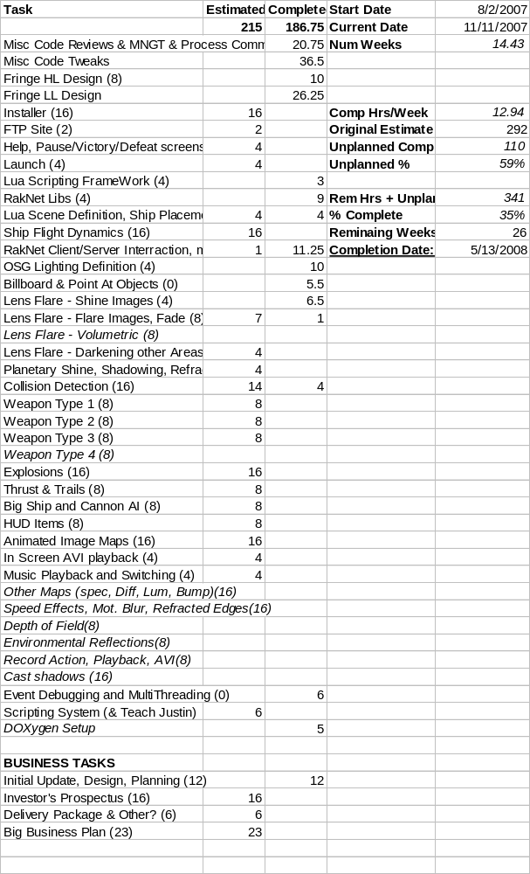

Art & Design Master Task List
Enter tasks based on ideal hours, (as if Justin were doing them). Use this rough formula when deciding on estimates: Justin, I took a stab at this gauge for you, based on your estimate of a modeling and texturing a ship taking 16 hours. You can certainly adjust this to your own needs.
- 2 hrs. Tasks that are trivial almost trivial, can be completed in one easy sitting.
- 4 hrs. Use this for tasks that you think might be easy, but there might be some part you are not 100% sure about. This is either a long weekend sitting or a couple of days mid-week working part time.
- 8 hrs. Use this for slightly larger tasks that you are fairly sure of, there are no serious unknowns. This is probably about a week of work part time.
- 16 hrs. Use this for larger tasks where this is some degree of uncertainty. Most of the tasks are probably at the 8-16 hr scale. If a task is more than 16 hrs, break it up into smaller pieces.

Planned Tasks
These are not necessarily prioritized, just listed in the order they were conceived. Make tasks that are not critical, but can be added at the end as we are looking for investors, italic. Items that are immediate priorities are bold. Justin: I tried to take a swag here at the tasks with (what I thought was a conservative) estimate. Please update these estimates, adding tasks where needed. If you are going to use any existing models, but only need to texture, you should update the estimates for these as well. The estimated completion date at our current rate is:

Current Date | Act Hrs / Avg Hrs | % Complete | Estimated Completion
9/3/2007 | 12 |  | 8/11/2008
9/9/2007 | 0 |  | 1/11/2009
9/15/2007 | 2 / 5.92 | 7% | 8/6/2008
9/23/2007 | 10 / 6.59 | 15% | 4/4/2008
9/30/2007 | 6.5 / 6.57 | 16% | 5/7/2008
10/7/2007 | 0.5 / 5.69 | 16% | 6/13/2008
10/14/2007 | 0 / 4.96 | 16% | 7/26/2008
10/21/2007 | 4 / 4.85 | 17% | 8/27/2008
10/28/2007 | 0 / 4.36 | 17% | 10/8/2008
11/4/2007 | 24.5 / 6.22 | 23% | 7/19/2008
11/11/2007 | 14.5 / 7.58 | 26% | 6/12/2008

